Data Operations - Insert

Definition
# Source: AI Source: Provided by: [Data Path: Persons Table -> ID Column: 1, Name_En Column: Motasem Essam] -> From: [ChatGPT] on [12/10/2025]
Insert is the process of adding new data or records into a database, file, or storage system.
- It ensures that new information is captured and stored for future use.
Key idea:
It’s like putting a new file into a filing cabinet so it is available when needed.

Characteristics of Insert
# Source: AI Source: Provided by: [Data Path: Persons Table -> ID Column: 1, Name_En Column: Motasem Essam] -> From: [ChatGPT] on [12/10/2025]
- Adds new rows or records without affecting existing data
- Can be single-record insertion or bulk insertion
- Often done using queries, forms, or file upload tools
- Ensures data is up-to-date and complete
- Works in databases, spreadsheets, or other storage systems

Example
# Source: AI Source: Provided by: [Data Path: Persons Table -> ID Column: 1, Name_En Column: Motasem Essam] -> From: [ChatGPT] on [12/10/2025]
A student database:
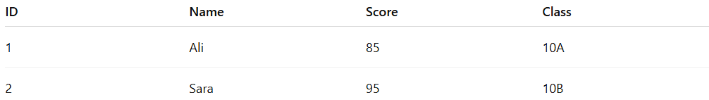
ID | Name | Score | Class
1 | Ali | 85 | 10A
2 | Sara | 95 | 10B
- Insert a new student, Omar:
- SQL Query: INSERT INTO Students (ID, Name, Score, Class) VALUES (3, 'Omar', 80, '10A')
Updated Table:

ID | Name | Score | Class
1 | Ali | 85 | 10A
2 | Sara | 95 | 10B
3 | Omar | 80 | 10A

Example Section
# Source: AI Source: Provided by: [Data Path: Persons Table -> ID Column: 1, Name_En Column: Motasem Essam] -> From: [ChatGPT] on [12/10/2025]
A teacher adds a new student record:
Name | Score | Class
Omar | 80 | 10A
- The new student is inserted into the database.
- This is insert-based data operation, ensuring data completeness and up-to-date records.

Advantages
# Source: AI Source: Provided by: [Data Path: Persons Table -> ID Column: 1, Name_En Column: Motasem Essam] -> From: [ChatGPT] on [12/10/2025]
- Adds new information to the system
- Keeps data current and complete
- Can be automated for bulk data entry
- Supports efficient record management

Disadvantages
# Source: AI Source: Provided by: [Data Path: Persons Table -> ID Column: 1, Name_En Column: Motasem Essam] -> From: [ChatGPT] on [12/10/2025]
- Incorrect insertion may cause data errors or inconsistencies
- Duplicate records may occur if validation is not applied
- Large bulk insertions may slow down the system temporarily
- Requires proper data validation to maintain data quality

